**Help participants reflect on the social and emotional aspects of the movie and consider how their own emotions work.**

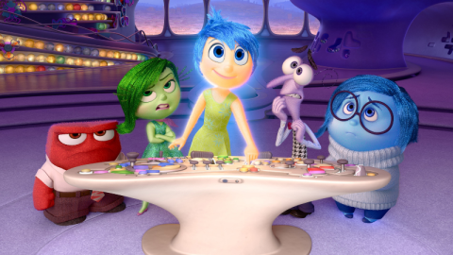

Pixar's [*Inside Out*](https://www.commonsensemedia.org/movie-reviews/inside-out) is a movie that's all about feelings, and this makes it perfect for sparking discussions with kids about social and emotional learning. Since the central characters all embody a different emotion, participant learn to see parts of themselves or their experiences in each character.

Refreshingly, the movie doesn't make learning about emotions such a heavy-handed endeavour. By getting to know and love each character, participant naturally come to understand that emotions are complex, and that we need the entire range of feelings to fully capture the meaning of life experiences.

**Things to Know Before You Show Pixar's *Inside Out* to Your Participants**

This guide offers two different approaches to teaching *Inside Out*:

1. Show a few specific clips along with discussion questions.
2. Show the entire film with a more in-depth lesson plan and handout.

Feel free to use either approach, or even combine the two into one lesson (or an entire unit) based around the movie. If you only have a single class period, showing just a few key clips below might be perfect. If you decide to help participant delve deeper into the topic, you might show the entire film and have more extensive discussions over multiple days. Of course, you could also use some combination of the two, adapting the lesson to best suit your participant's needs.

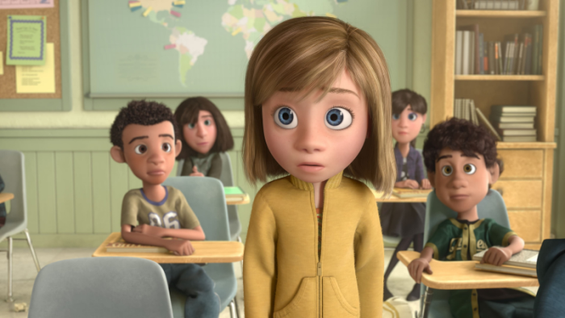**Objectives**

With this lesson, you can help your participants:

* Identify their own feelings.
* Think through what it means for emotions to have context.
* Acknowledge the value of having a range of emotions.
* Connect their own personal experiences to the movie's messages.
* Identify their own perspective and be curious about the perspectives of others.
* Explore the ways they identify their own emotions, including somatically.
* Think about the ways they currently self-regulate and explore possibilities for other ways.
* Think about helpful versus unhelpful responses to emotions from themselves and others.

***Inside Out* Clips and SEL Discussion Questions for participant**

If you only want to show brief parts of the film and discuss them with participants, use these helpful clips to get you started. You can also use these in conjunction with the longer plan below.

The time stamps can help you pick and choose your areas of focus. Use as few or as many clips as you see fit, but keep in mind that you may need to introduce the movie's overall plot and talk through some of what happens before or after each clip.



**Clip #1: When Dad says Riley can't have dessert if she doesn't eat her broccoli, Anger "blows his top." (3:48-4:06)**

* Use this scene to talk about idioms. Have individual draw another emotion-related idiom (ex. cry your eyes out, bent out of shape, spaced out, down in the dumps, etc.). Brain storm these idioms or give the idiom and discuss what it could mean
* Ask participant: Have you ever considered how the zone you are in can impact other people who are nearby?



**Clip #2: Joy explains core memories and how they feed the "islands of personality." (4:37-6:38)**

* Have individual draw and/or write about their core memories and/or their own islands of personality.



**Clip #3: Riley sees her new house, and she experiences a range of emotions. (8:43-9:50)**

* Discuss: How do emotions influence how Riley feels about the new house? How can she go from feeling sad about her new room to feeling excited about how it will look? The room didn't change -- what *did* change, and how?



**Clip #4: A joyful memory becomes sad, as Riley remembers a moment from the trip. (11:51-12:54)**

* As we grow up, sometimes feelings get more complicated. In this scene, a memory that was purely happy becomes sad. In the movie, this is caused by Sadness touching the memory. Ask participant: In the real world, why might sadness "touch" a memory?
* Explain to participant that this movie was inspired by a real 11-year-old. Her dad wanted to show what it's like to have complicated feelings as you grow up. Ask individual: Do you think he did a good job? What would you do differently?



**Clip #5: Joy argues with the other emotions about how Riley should feel on the first night after the move, using the phrase, "It could be worse." (16:01-17:14)**

* Riley has her own room in a house in San Francisco, which is more than many people have. Ask individual: Is Joy right -- could it be worse? Should Riley not feel angry, sad, or scared? Does thinking about how things could be worse change how you feel? Why or why not?



**Clip #6: Mom thanks Riley for being their "happy little girl" and wants them both to keep smiling for Dad. (17:10-18:06)**

* Riley isn't feeling happy when her mom calls her their "happy little girl." She wants Riley to "put on a happy face." Ask participant: Have you ever kept smiling even when you weren't happy? What did it feel like? Did it help the situation? Did it help you?



**Clip #7: Joy asks Sadness to stay confined inside of a circle and not participate in Riley's first day at her new school. (20:50-21:27)**

* Joy wants to keep Sadness in a tiny circle during Riley's first day at her new school. Ask individual: What's the result? In real life, can we keep our emotions exactly where we want them?



**Clip #8: Riley starts crying in class as she talks about her home in Minnesota, and Joy tries to prevent a sad memory from becoming a core memory. (22:09-26:08)**

* Even though she didn't want to, Riley cries in class. Ask individual: How much control do we actually have over our emotions?
* How do other characters react to this?
* Is this behaviour expected from 1. Riley. 2. Those around her.



**Clip #9: Without Joy around, Riley snaps at her parents during dinner, and her dad "puts his foot down." We also get a peek into her parents' emotional headquarters. (26:26-30:08)**

* The movie doesn't focus on the parents' feelings or experiences much. Ask individual: How do you think Riley's parents are feeling about the move or having new jobs? How do you think they feel about making Riley move? What are the emotions in charge for Mom? For Dad? Why do you think people react to the same situation in different ways?



**Clip #10: Mind workers vacuum up faded memories to send them to the memory dump. (34:39-36:04)**

* Use this opportunity to briefly talk with individual about how the movie uses examples from real parts of brain science, like long-term memory, abstract thought, and dreaming. Another example is the brain "getting rid of" unused information.
* Have individual pick one element of brain science to represent in a drawing (or any other type of creative output). Some other examples include learning, processing the senses, and daydreaming, among many others.)



**Clip #11: While talking to her friend from Minnesota, Riley suddenly feels angry. (36:00-36:36)**

* Ask individual: After Riley slams her computer, how do you think her friend felt? When we lose control of our feelings and do something that hurts someone else, we may not have meant to hurt them. If we didn't mean to, are we still responsible? What can we do next?



**Clip #12: Joy, Sadness, and Bing Bong take a shortcut through Abstract Thought. (41:40-43:35)**

* An abstract thought is something that's not concrete -- or not easy to explain -- like love or loneliness. Ask participant: How did the movie makers show us what abstract thought is?
* Have participant take an abstract idea and show it in a concrete way in a drawing (or any other type of creative output).



**Clip #13: Riley's hockey tryout is very frustrating and upsetting. (45:16-46:50)**

* Ask participant: Riley is good at hockey and usually enjoys it, so why are the tryouts so hard?



**Clip #14: Both Joy and Sadness try to comfort Bing Bong when his wagon is thrown in the dump, and Sadness is the one to succeed. (47:04-49:39)**

* Having empathy is about understanding what someone else is feeling. Ask participant: Why does Bing Bong respond to Sadness but not Joy?
* Ask participant: Why are movies a great way to see other people's perspectives and practice using empathy?



**Clip #15: Joy and Bing Bong are stuck in the memory dump. Joy feels sad herself (and realizes that emotions work together), and Bing Bong sacrifices himself to make sure Joy can escape. (1:06:27-1:13:35)**

* Ask participant: What does Joy realize as she holds Riley's memory the moments after losing the hockey game? Why does Bing Bong decide to let himself fade away?
* Introduce participant to the idea of nostalgia. Ask them: When you think about happy memories from when you were little that may be fading, how do you feel?



**Clip #16: Riley's parents realize she's gone -- Riley struggles with her decision, returns home, then shares her sadness with her parents. (1:13:40-1:23:54)**

* Explain that Riley choosing to run away and try to get back to Minnesota is one way to deal with her feelings. Then ask participant: What's the impact of that choice? What are some other ways she could have expressed her feelings?

**WRAP UP:**

Ask individual:

* How did the characters get along with each other when they were in the different zones?
* What were others thinking about them when they were in the yellow or red zone and their behaviour was unexpected?
* What did people think of them when their behaviour in a zone was expected?
* In what zone do you feel you get along best with others or a most successful?